**Controls in Section:**

**Icon/Image Control: Used to Add Icons or Images in User Interface Design**

**2 Steps to Add images in UI:**

**Step1: Load Images to Directory from some local system. ( Using Binary File rule we can load images to Directory/Server)**

**Step2: Map/Reuse Images from Directory to Section using Image Control.**

**Create Binary File Rule:**

**Binary File is a Technical Rule:**

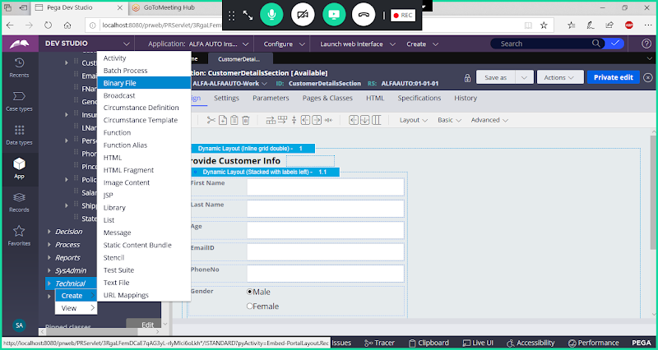

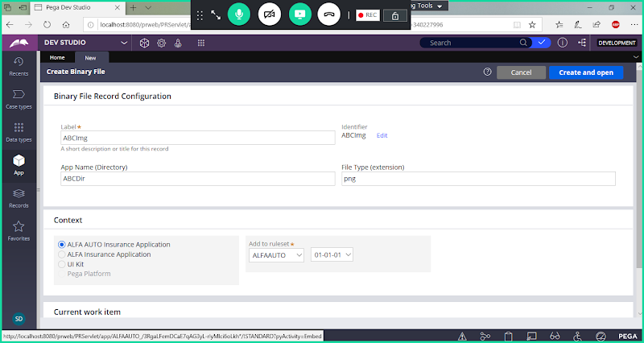

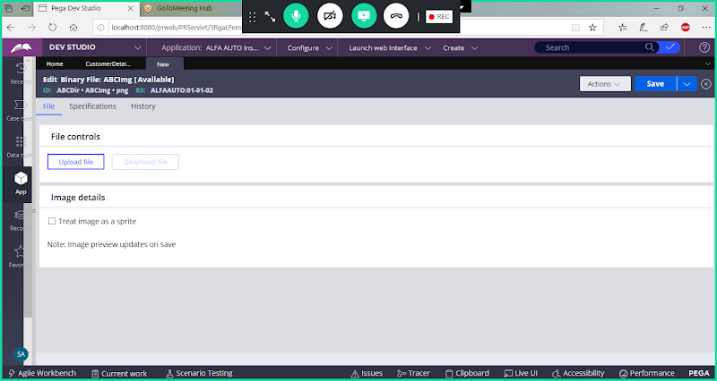

**Click on Upload File**

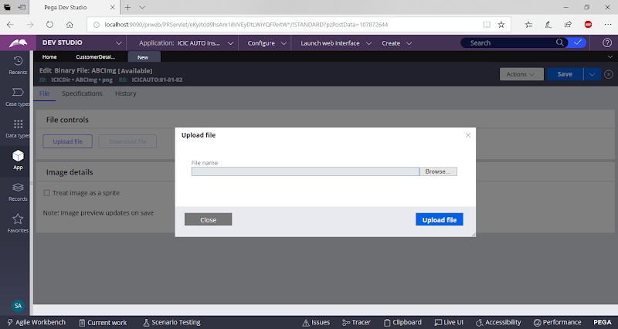

**Browse the File & Click on Upload**

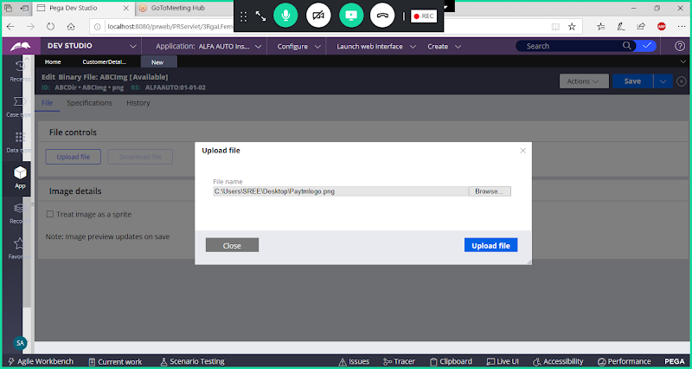

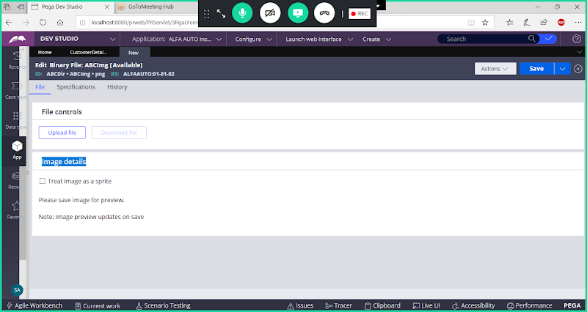

**Save Binary File Rule to Preview the Image**

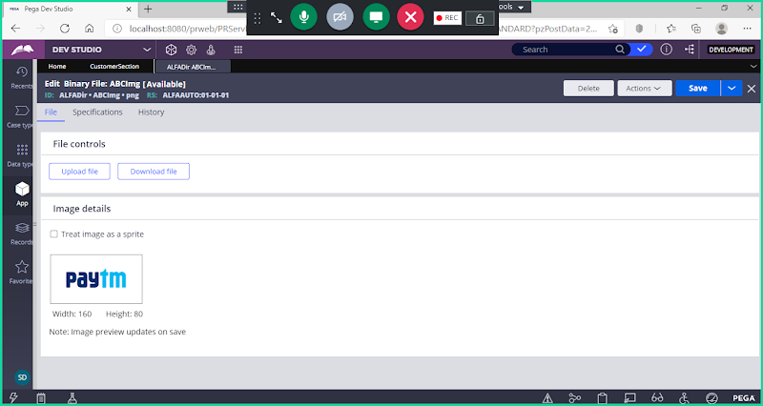

**Open Any Existing Section & Add New Dynamic Layout**

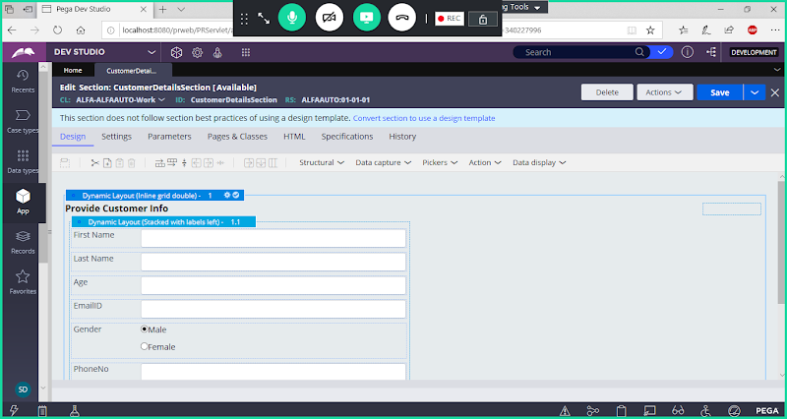

**Add Dynamic Layout Before Layout1**

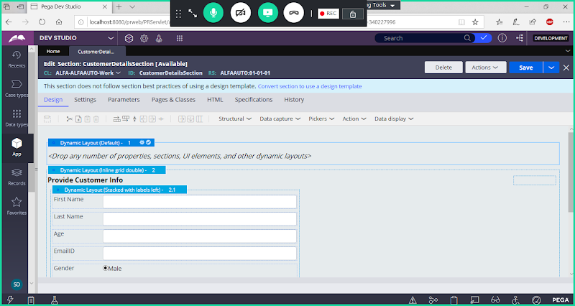

**For Layout 1 - Set Layout Format as Inline:**

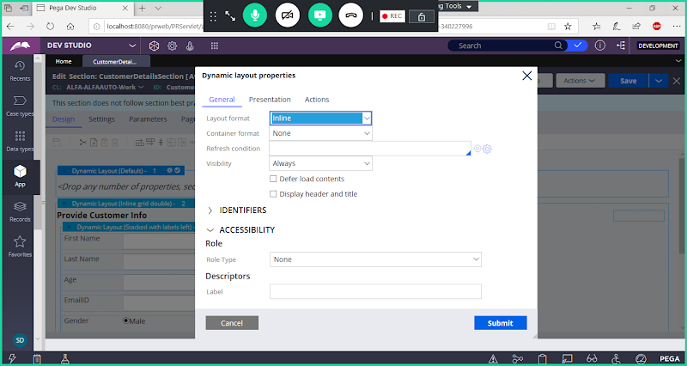

**Submit**

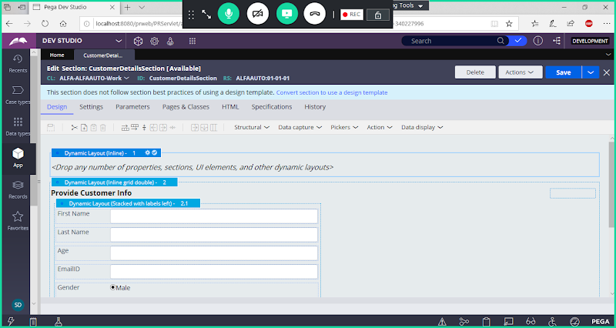

**Add Image Control in Layout 1 ( From Data Display )**

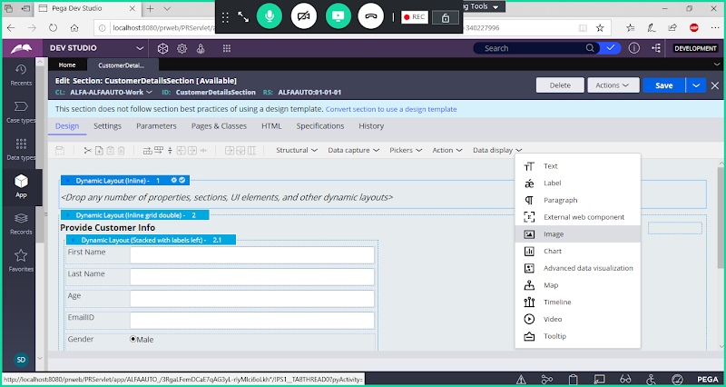

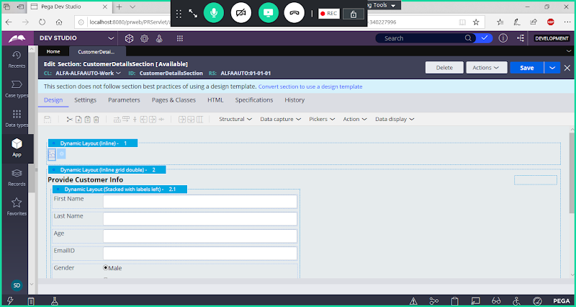

**Double click on Image Control Settings**

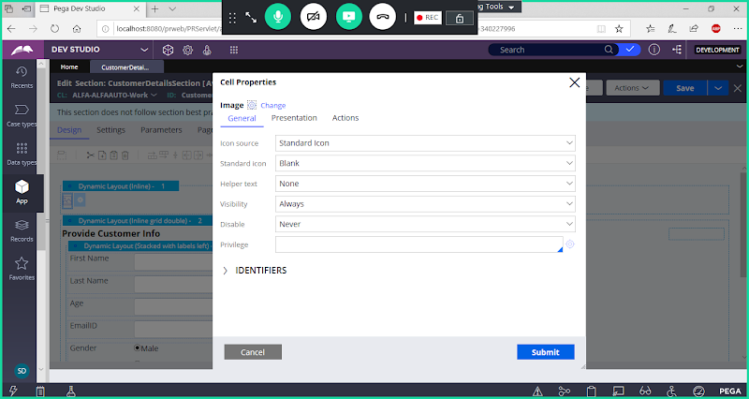

**Under Icon Source: Select Image**

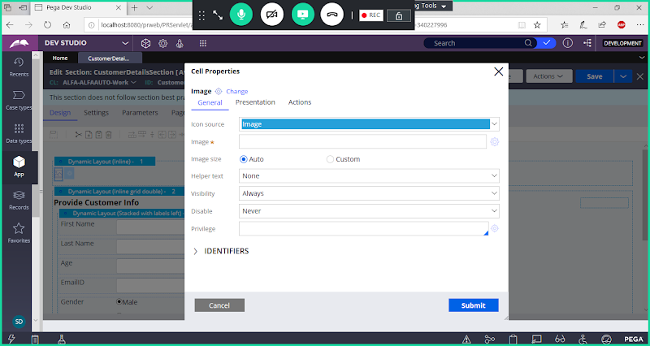

**Now Open Image Settings**

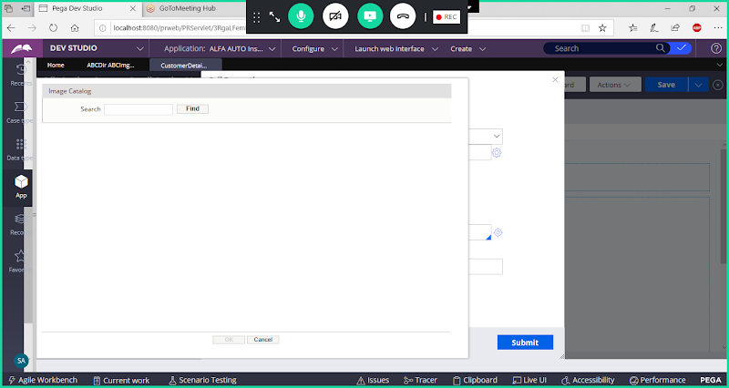

**In Image Catalog type Image Name & Search ( ABCImg)**

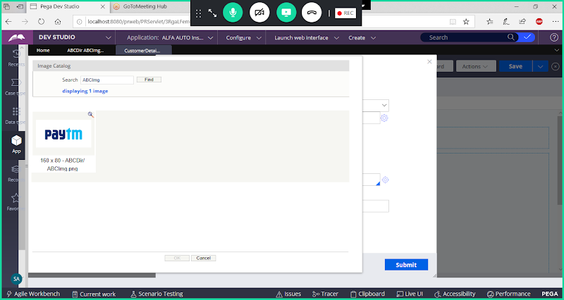

**Select the Image**

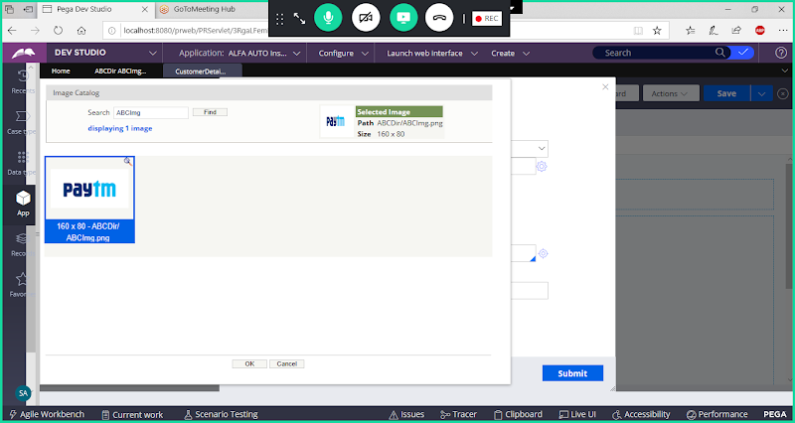

**Clcik on Ok**

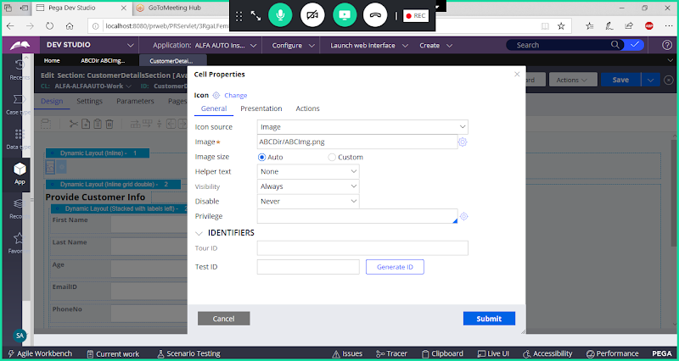

**Click on Submit**

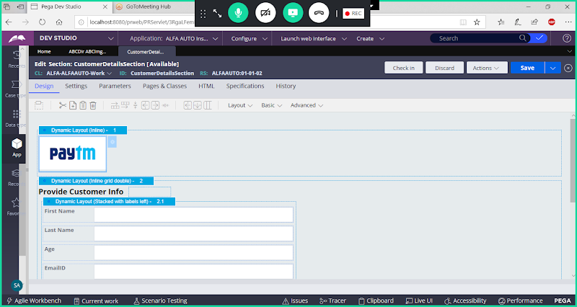

**====**

**Link Control:**

**Req:  Mapping Link Control Using any Existing Local Action Rules:**

**Use Same Design used for Image.**

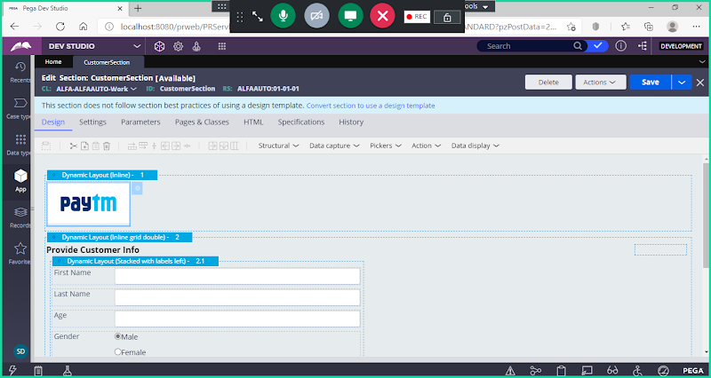

**Add Link Control Next to Icon/Image**

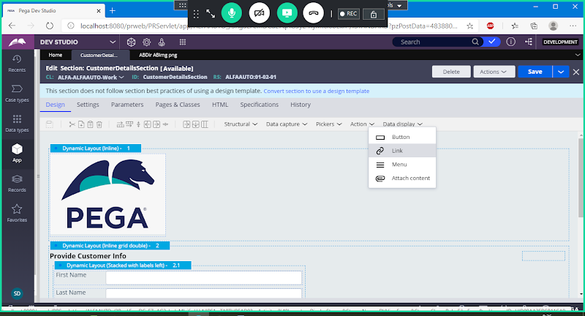

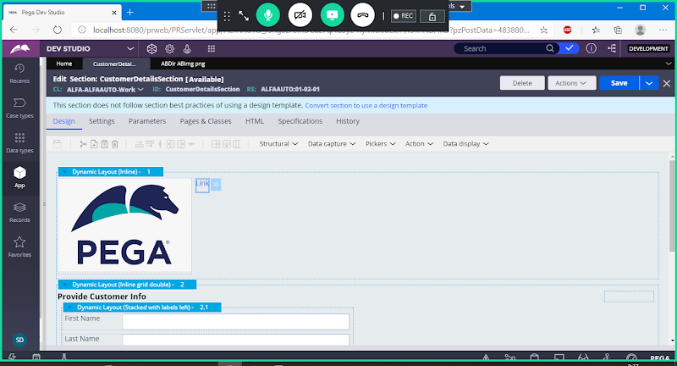

**Double Click on Link Control & Add Caption**

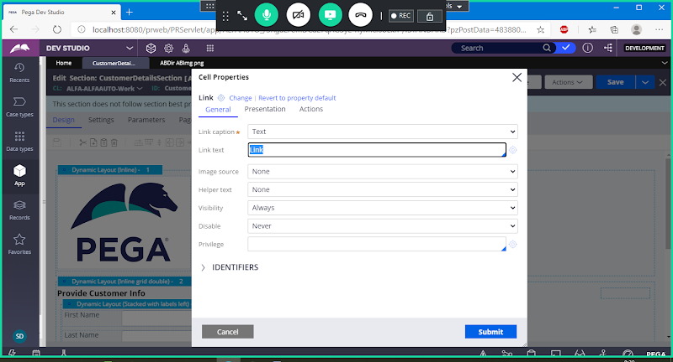

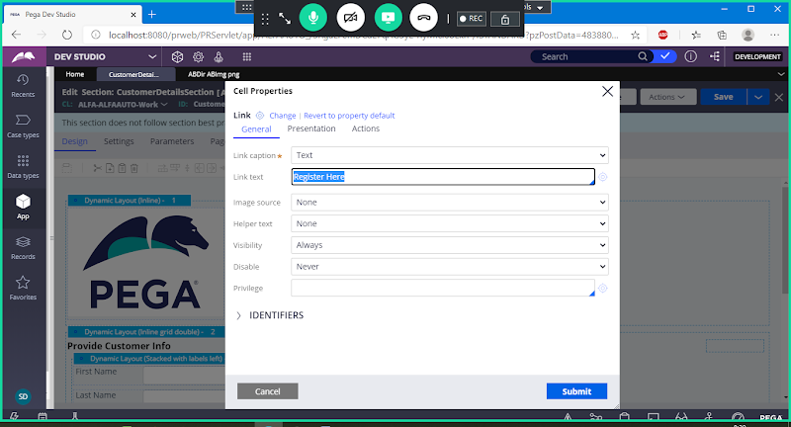

**Submit**

**Add New Properties under Work Layer: UserName & Password**

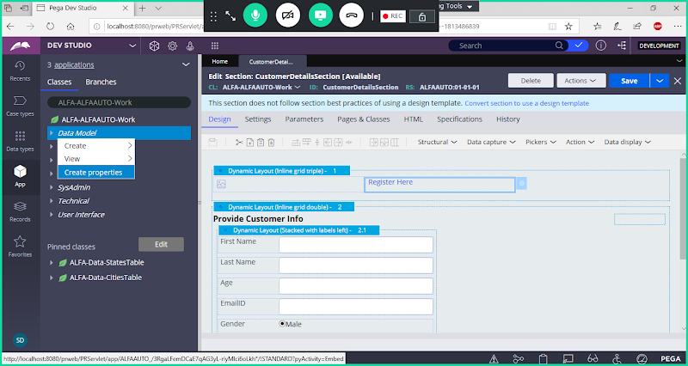

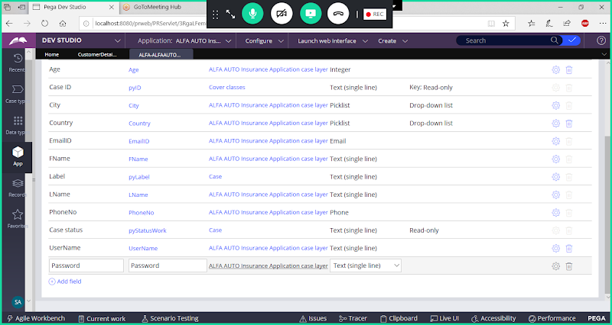

**Create a New Section:**

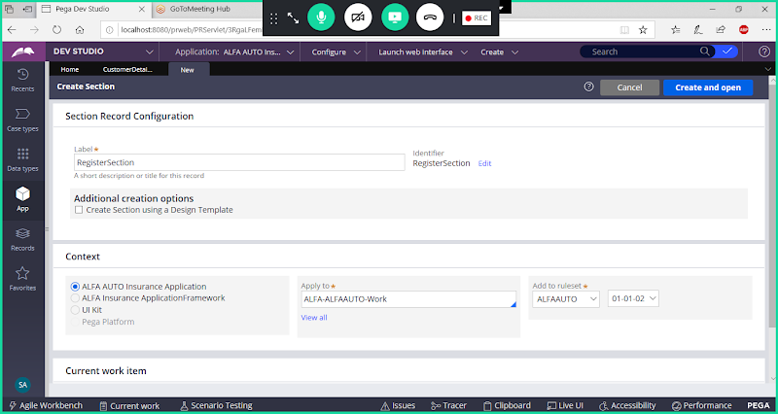

**Open**

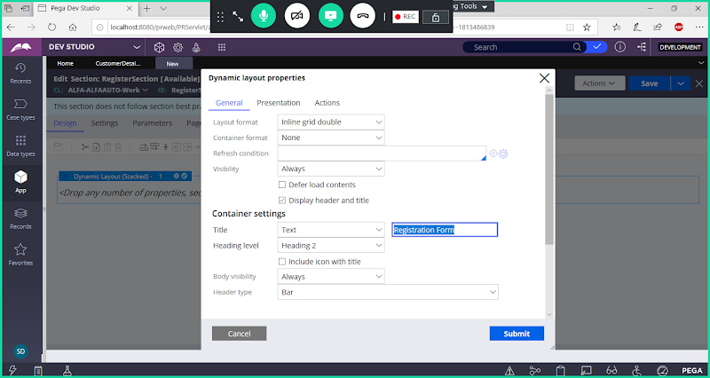

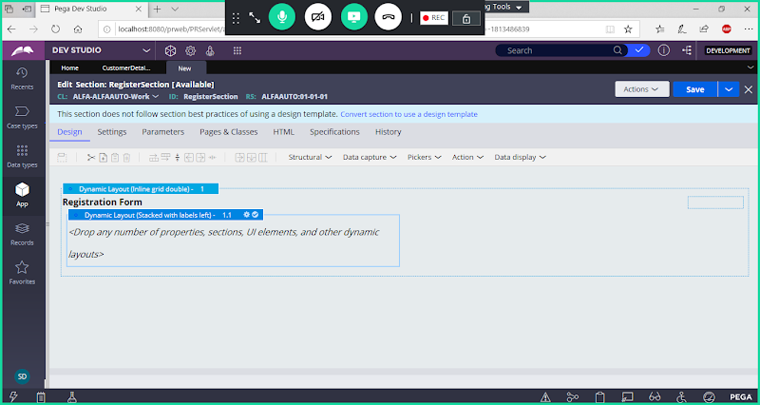

**Now Add Properties**

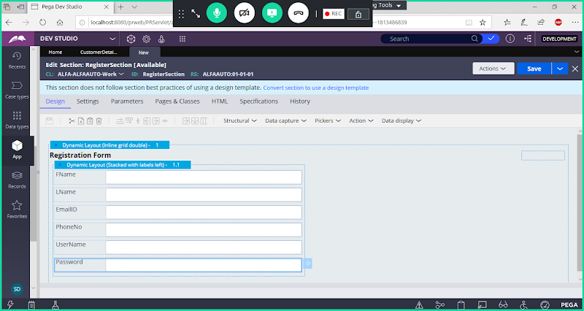

**For Password & Confirm Password Field Change Control to Password**

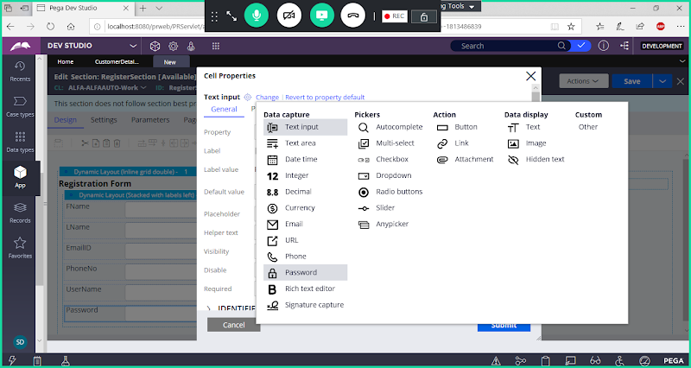

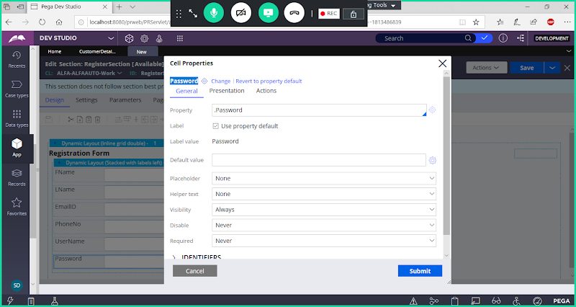

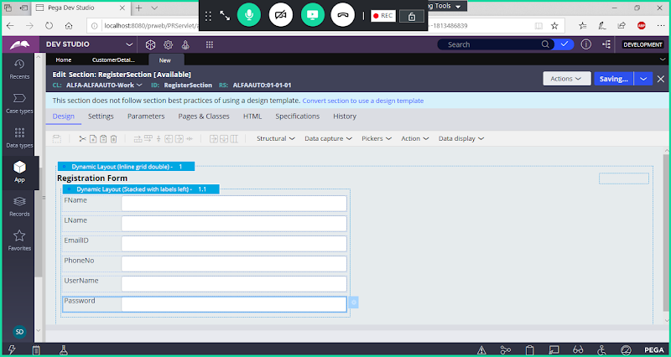

**Save Section**

**Create Local Action:**

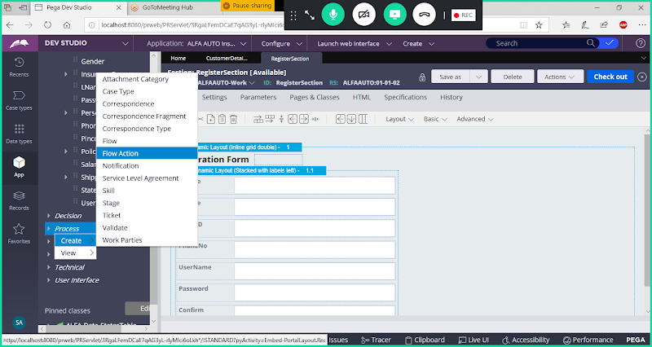

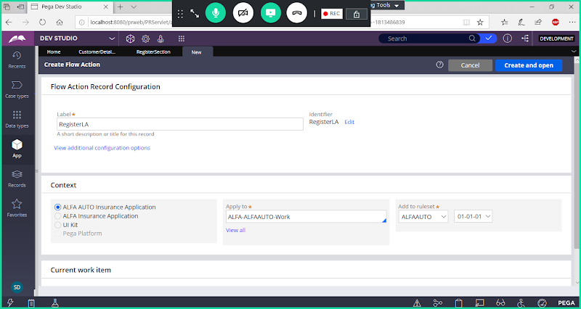

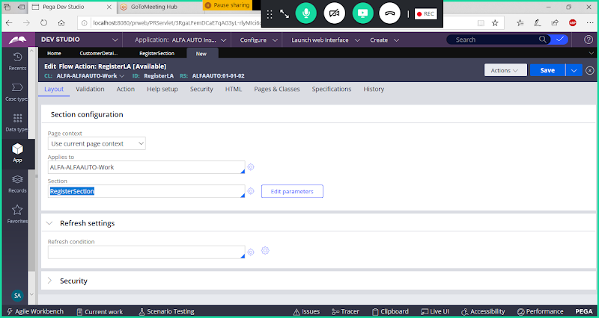

**Go to Action Tab & Change Indicator -> LocalAction**

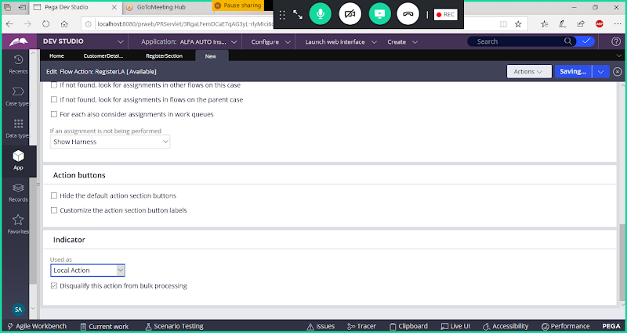

**Save Local ACtion**

**Now Call Local Action in Link Control Actions:**

**Open Customer Details Section:**

**Open Link Settings**

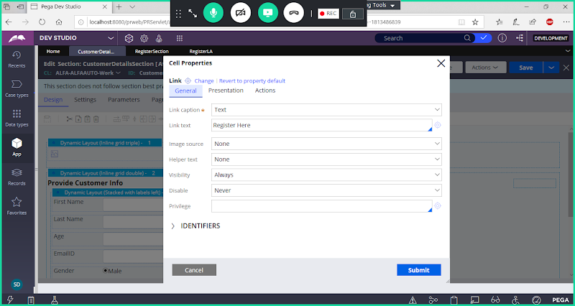

**Go to Actions Tab:**

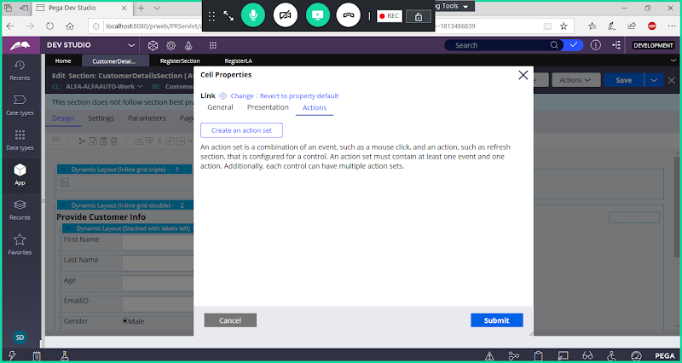

**Create an Action Set**

**Event Type: Click**

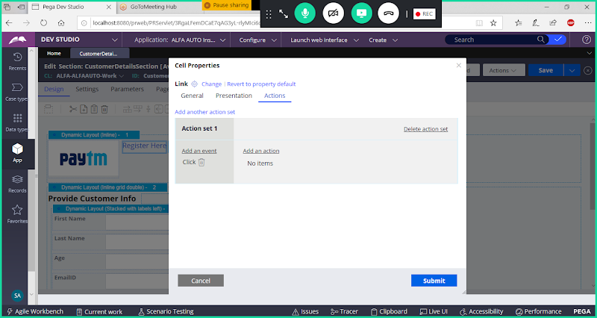

**Action Name: Launch Local Action**

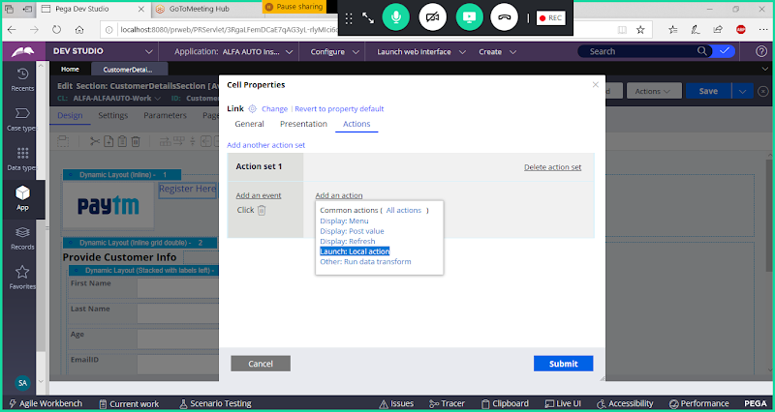

**Select Action : Launch Local Action**

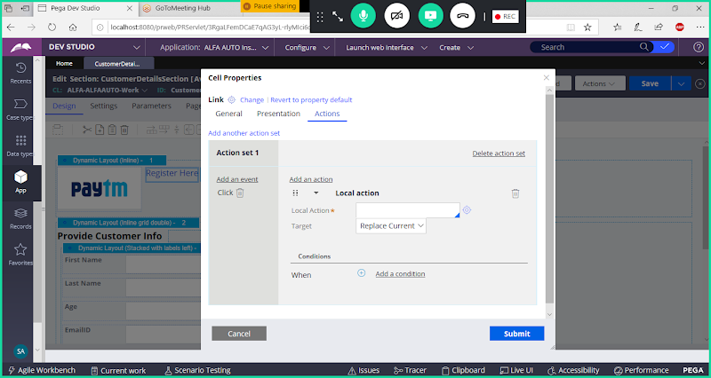

**Fill Parameters:**

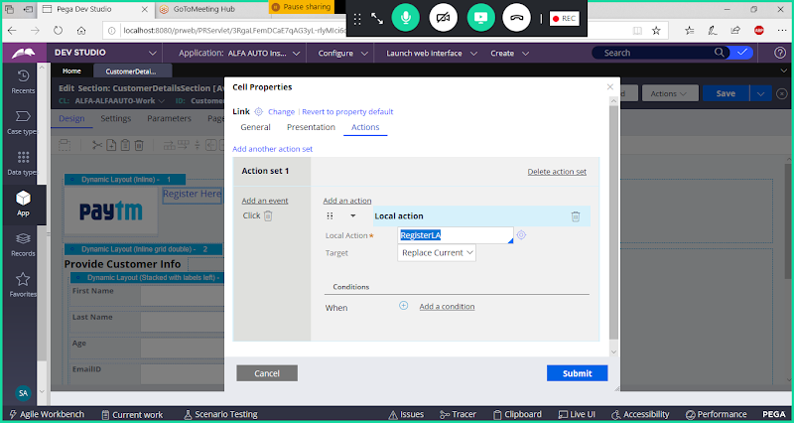

**Change Target: Modal Dialog**

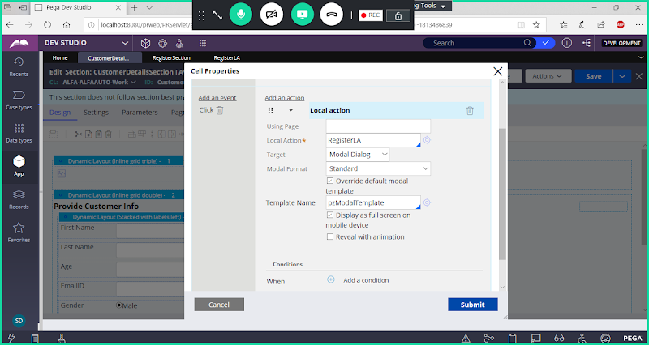

**Clcik on Submit**

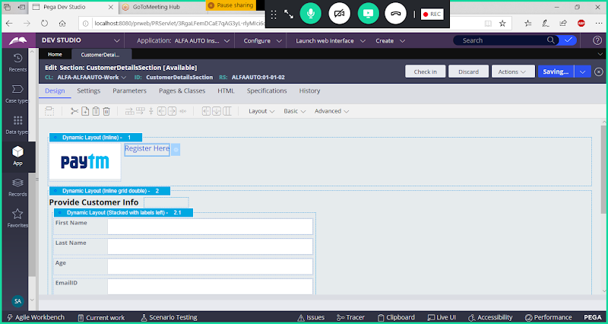

**Save Section**

**Run Customer Flow:**

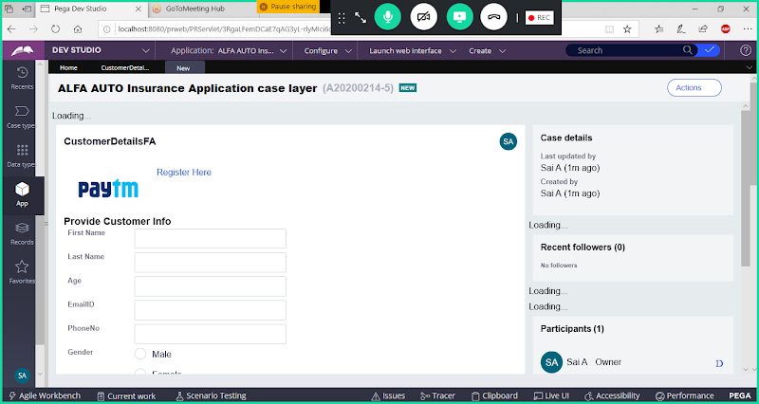

**Click on Link**

